ASSINGMENT 2
24K-0024

Q1
import requests

def get_api_url():
try:
with open("api.txt", 'r') as f:
api_url = f.readline().strip()
if not api_url:
print("api.txt is empty")
return None
return api_url

except FileNotFoundError:
print("File not found")
return None

except Exception as e:
print("Error: ", e)
return None

def fetch_live_matches(api_url):
try:
response = requests.get(api_url)
if response.status_code != 200:
print("Error: Received status code ", response.status_code)
print("Response: ", response.text)
return None
return response.json()
except requests.exceptions.RequestException as e:
print("Network error")
print("Details: ", e)
return None

def print_api_status(data):
if not data:
print("No API data to display")
return

for key, value in data.items():
if key not in ["data", "apikey"]:
print(key, ":", value)

def get_match_details(api_url):
try:
response = requests.get(api_url)
if response.status_code == 200:
data = response.json()

if data.get("status") == "success" and "data" in data and data["data"]:
match_list = data["data"]

for match in match_list:
print("Match:", match.get('name', 'N/A'))
print("Status:", match.get('status', 'N/A'))
print("Venue:", match.get('venue', 'N/A'))
print("Date:", match.get('date', 'N/A'))
print("-" * 30)

scores = match.get("score", [])
if scores:
print(" Score Details:")
for inning in scores:
print(f" Inning : {inning.get('inning', 'N/A')}")
print(f" Runs : {inning.get('r', 'N/A')}")
print(f" Wickets: {inning.get('w', 'N/A')}")
print(f" Overs : {inning.get('o', 'N/A')}")
print(" " + "-" * 25)
else:
print("No score details available.")
print("-" * 30)
else:
print("No live matches found or an unknown error occurred.")

else:
print("Error, failed to fetch data. Status code:", response.status_code)
print("Response:", response.text)

except requests.exceptions.RequestException as e:
print("Network error occurred:", e)

url = get_api_url()
print("Api url:", url)

if url:
data = fetch_live_matches(url)
if data is None:
print("Unable to retrieve data from API")
else:
print_api_status(data)
get_match_details(url)
else:
print("No API URL found. Please check api.txt.")

Output

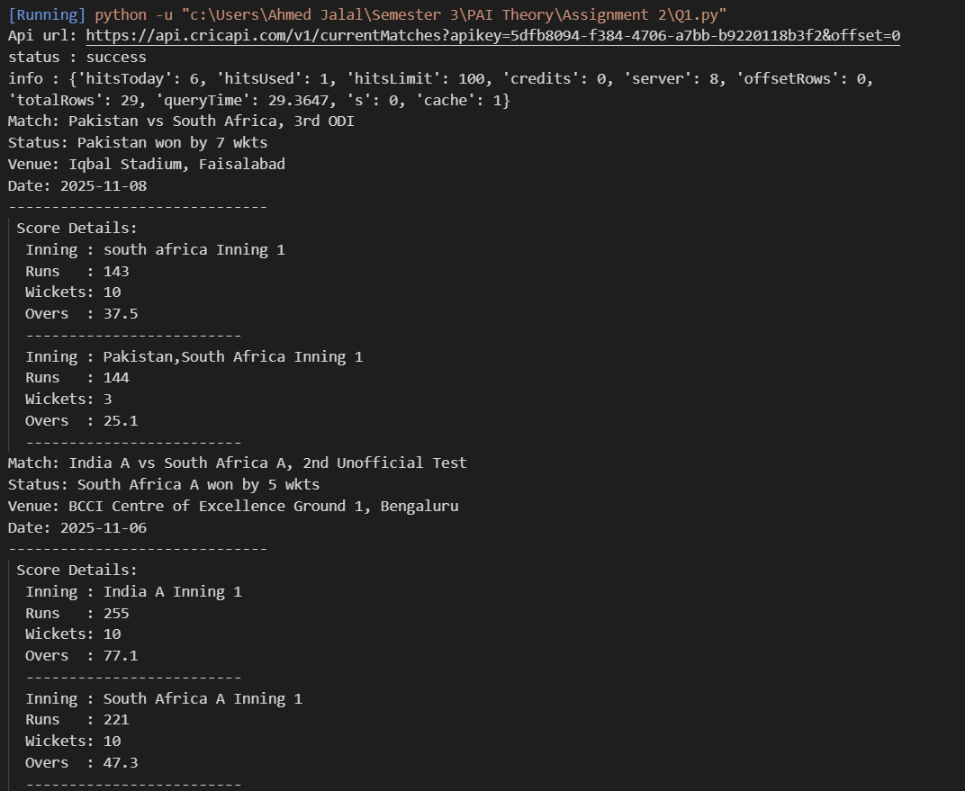

Q3
import pandas as pd
df = pd.read_csv("Titanic-Dataset.csv")
df.info()
df['Age'] = df['Age'].fillna(df.groupby(['Pclass', 'Sex'])['Age'].transform('median'))
df['Embarked'].fillna(df['Embarked'].mode()[0], inplace=True)
df.drop(columns=['Cabin'], inplace=True)
df

df.insert(10,"FamilySize",df['SibSp'] + df['Parch'])
df['IsAlone'] = 0
df.loc[df['FamilySize'] == 0, 'IsAlone'] = 1
df['Age'] = df['Age'].astype('int64')
df
df.to_csv("titanic_cleaned.csv", index = False)

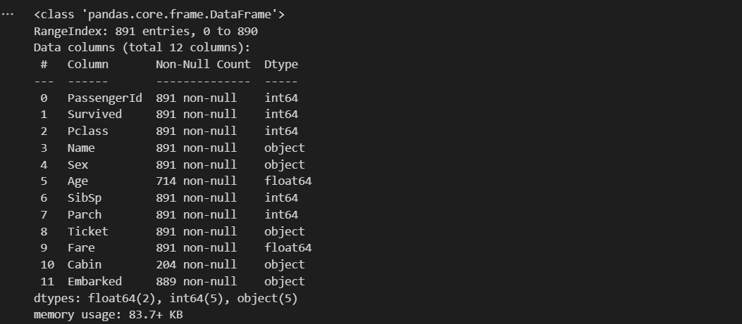
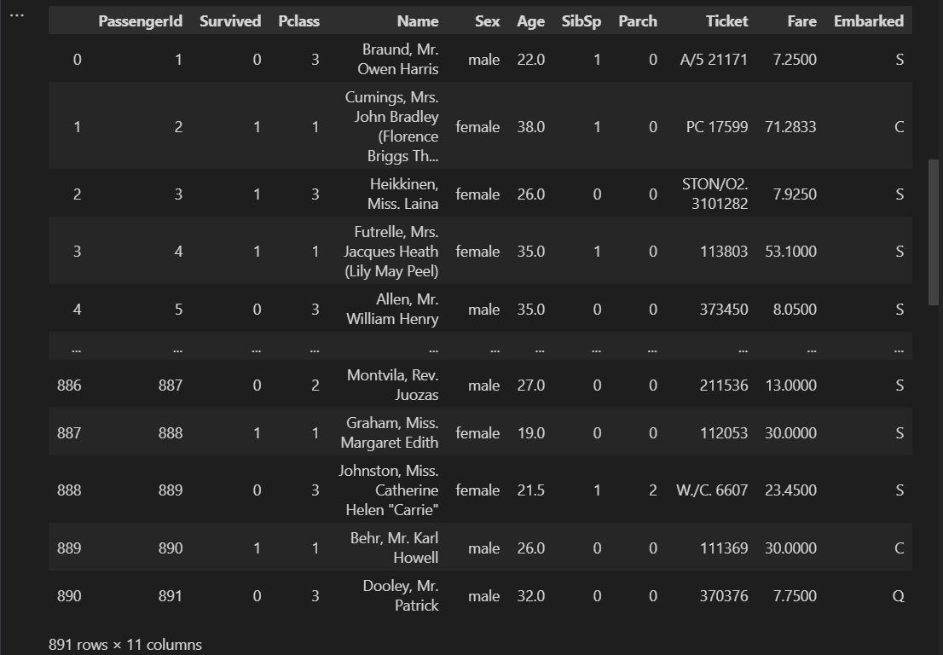
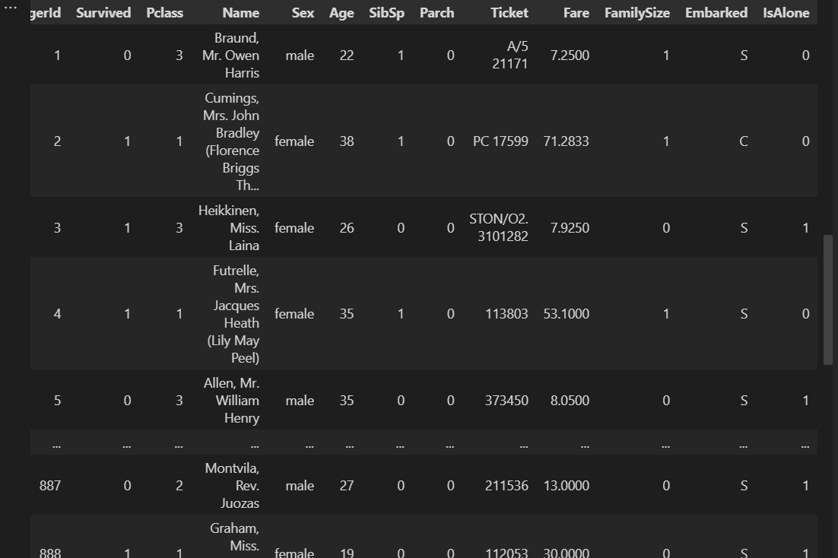

Q4:
import pandas as pd
df1 = pd.read_csv("titanic_cleaned.csv")
df2 = pd.read_csv("ticket_fares.csv")

df3 = pd.merge(df1, df2, on='Ticket')
df3
age_labels = ['Child', 'Teen', 'Adult', 'Senior']
age_bins = [0, 16, 25, 50, 100]
df3['AgeGroup'] = pd.cut(df3['Age'], bins = age_bins, labels = age_labels, right = True)
survival_rate = df3.groupby(['Sex', 'AgeGroup'], observed= True)['Survived'].mean()
df3

print(survival_rate)
with open('report.txt', 'w') as f:
f.write("The anaylsis shows that women and children had higher survival rate than men." \
"The survival rate of women ranges from 47.8% for child to 93.3% for seniors. On the other" \
"hand the survival rate for men ranges from 10% for seniors to 25.3% for children. However " \
"in females the children had the least survival rate compared to men where children had the " \
"higest survival rate. The data supports the Women first hypothesis but it not supports children" \
"first for female category")

class_survival = df3.groupby("Pclass")['Survived'].mean()
print(class_survival)
fare_labels = ['Low', 'Medium', 'High', 'Very High']
df3['FareBin'] = pd.qcut(df3['Fare_x'], 4, labels = fare_labels)
fare_survival = df3.groupby('FareBin', observed=True)['Survived'].mean()
print(fare_survival)
df3
with open('report.txt', 'a') as f:
f.write('The data supports the wealth hypothesis as the survival rate as in Passenger class' \
'the survival rate ranges from 23.9% for class 3 to 68.9% for class 1. The survival rate ' \
'increases as class increases. In Farebin the survival rate ranges from 22.9% for low fare ' \
'to 60.9% for high fare. It increases for each fare class.')

OUTPUT:
